**DEPLOYMENT MANUAL**

**Project Name:** SARS Covid-19 Detection Through AI

**Team:** Mission Possible

**Project Description:**

This is a web application that allows users to upload CT scan reports and receive accurate results indicating if they have COVID-19. It employs AI and deep learning techniques to analyze the scan images and return a prediction.

**Key Features:**

* User registration and login
* Upload CT scan images
* AI-powered analysis for COVID-19 prediction
* Present results to user
* Track scan history over time
* Doctor appointment scheduling
* Real time analysis of the present covid-data

The application aims to provide an easy way for users to check if they potentially have COVID-19, right from the comfort of their homes. By using past scan history it can also show trends over time. Appointment scheduling and ability to order kits makes it a comprehensive solution.

**Technologies:** Convolutional Neural Networks TensorFlow, Keras Flask, Python

**System Requirements:**Operating System: Windows, Linux, MacOS RAM: 8GB minimum CPU: Quad-core processor Storage: 250GB HDD

**Software:** Python 3.6+, TensorFlow, Keras, Flask, MySQL Install Required Software Install Python 3.6+ Install TensorFlow, Keras, Flask, and other Python packages Install MySQL database

**Set up Database:** Create database schema Create user login credentials Import sample data if available

**Configure Application:** Set application properties like database URL, credentials Make any needed changes to file paths or settings

**Deploy Application Server:** Run Flask application on production server Configure WSGI server like Gunicorn or Waitress Enable HTTPS

**Testing:** Run integration tests and validate functionality Verify prediction results with sample images Stress test application load capabilities

**Clone the repository:** “Git clone- https://github.com/htmw/2023S-Team4.git”

**Source code :** https://github.com/htmw/2023S-Team4.git

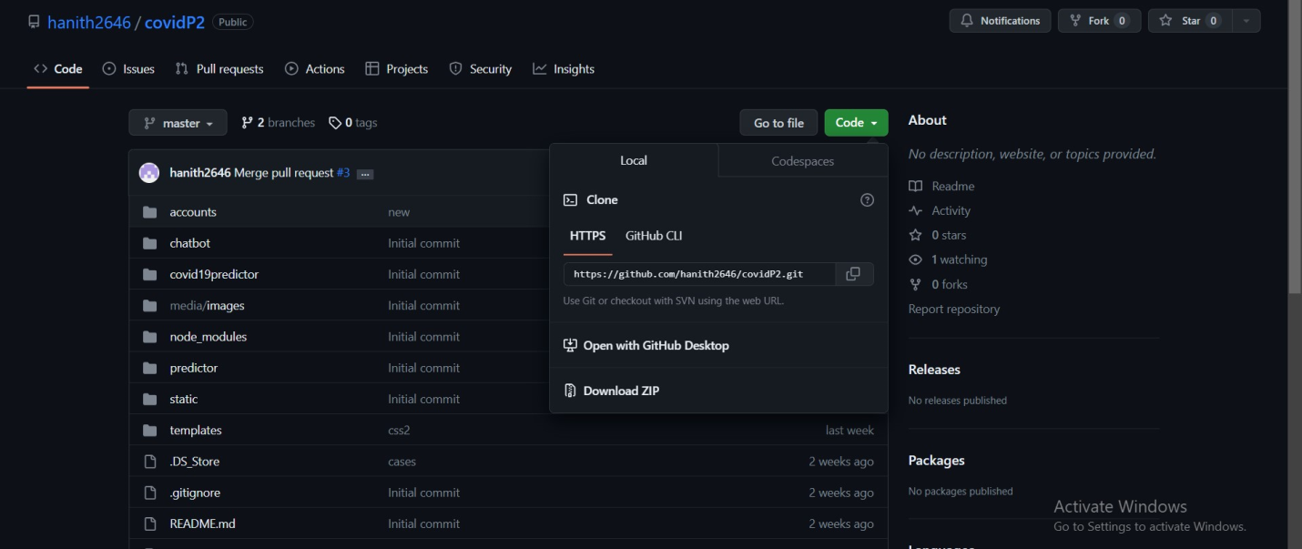

Download the zip folder and extract all the files

After extracting files. Open pycharm and open the extracted files.

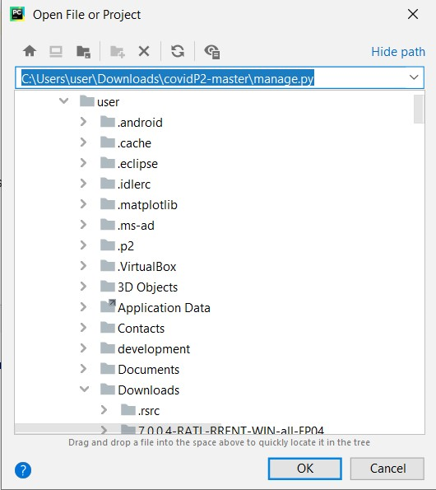

**Step 2**: Install Dependencies

```bash

pip install -r requirements.txt

```

**Open terminal and then install all dependencies**

**To runserver**

**Use this command line to run server- python manage.py runserver**

Then application will be started in unique sever-id click on it to to redirect from the default browser

Finally application will be running on default browser

LOGIN PAGE-

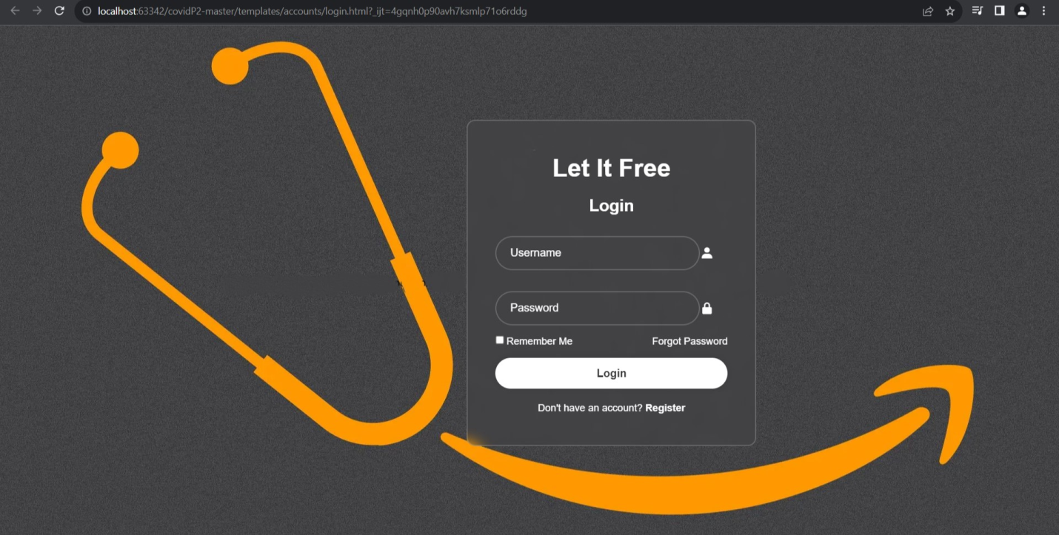

HOME PAGE-

HISTORY PAGE-

PERSONAL DETAILS FORM-

DOCTOR APPOINTMENT TAB-

COVID-19 TRACKER

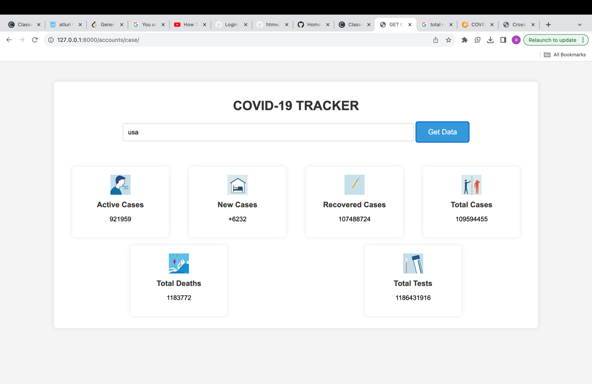

Covid 19 tracker for the active case ,new cases ,recovered cases ,total cases

SELF CHECK- ASSESSMENT

